34th New Jersey International Track and Field Meet
Saturday, August 7, 2021

Peddie School - Hightstown, New Jersey, USA

** UPDATED Schedule of Events as of THURSDAY August 5 **

ONLINE ENTRY ONLY

* Everyone must check in 60 minutes prior to scheduled race time. *
Rolling Time Schedule: we will not run more than 30 Minutes ahead.
The NJ International Meet games committee reserves the right to adjust the time schedule of the meet should there be forecasts of extreme weather conditions. Should that occur. we will do our best to alert all
athletes, coaches and meet personnel
Time | Track Events
1:00 PM | Opening Ceremony & National Anthem
1:10 PM | John Kuhi 400m Masters/Open
1:20 PM | Harry Nolan/George Sheehan Open and Masters Mile and the Mary Conry Memorial Women's Mile
**** | Chrissy D’Alessandro-Sheehan Memorial Women’s Elite Mile – entrants will run at 1:20 PM
1:35 PM | Dr. Matt Brown Open and Masters 100m**
1:40 PM | Frank Budd Memorial Elite 100m Trials**
1:45 PM | Fred Thompson Memorial Elite Women’s 100 meter Trials**  **8 Fastest overall from Elite and Open to Finals
1:55 PM | Art Smith Open and Masters 800m – Masters Race
2:00 PM | Art Smith Open and Masters 800m – Open & Elite Women
2:05 PM | Art Smith Open and Masters 800m – Open & Elite Men
**** | Joetta Clark Diggs Women’s Elite 800m – entrants will run at 2:00 PM
**** | Rich Kenah Men’s Elite 800m – entrants will run at 2:05 PM
2:10 PM | Elliott Denman 1 Mile Open Racewalk (M/W combined)
2:25 PM | Frank Budd Memorial Men’s 100m FINALS
2:30 PM | Fred Thompson Memorial Elite Women’s 100 FINALS
2:40 PM | Larry James Memorial Elite Men’s 400m
2:45 PM | Aliann Pompey Elite Women’s 400
2:55 PM | Andy Stanfield Memorial 200m (Men followed by Women)
3:00 PM | 4x400 Relay (late entry for the relay only open until 2:00 PM)
Field Events
1:00 PM |  | Al Blozis Memorial Shot Put: Women first, Men to follow
1:00 PM |  | Herbert Douglas Jr. Long Jump: Women & Men combined
2:15 PM |  | Norman Tate Triple Jump: Women & Men combined

** UPDATED Schedule of Events as of THURSDAY August 5 **

** Please note the revised start times for all events above. **

34th New Jersey International Track and Field Meet

Saturday August 7, 2021

Peddie School, Hightstown, New Jersey, USA

WE INVITE YOU TO JOIN US IN THE NJ INTERNATIONAL MEET, WHICH HAS HOSTED OLYMPIC AND WORLD CHAMPIONSHIP MEDALISTS AND ATHLETES FROM MORE THAN 40 COUNTRIES THROUGH THE YEARS

ONLINE ENTRY ONLY!

This track and field invitational is presented by the SHORE A.C. of New Jersey. Those athletes meeting the entry standards will be placed in the Elite Sections, all others will run in the earlier open/master sections. The fastest times from the Elite Trials and the Open Trials will run in the FINALS. Please see schedule and standards and enter the correct event online.
Athletes of all ages and abilities are encouraged to participate in this meet.

ONLY OPEN THROWING IMPLEMENTS WILL BE USED, NOT MASTERS

Venue: Peddie School, Hightstown NJ. Beynon All Weather Track Facility

UCS Starting blocks. Fast and smooth circles!

Meet Dir.: For information, questions, requests please contact Meet Director
David Friedman, (201) 290-0310. E-mail: davesac@comcast.net

Medical: Local First-aid squad is on call.

Entries: All Entries will be done online at www.directathletics.com

Entries close 8:00 PM on Thurs., August 5th (NO additions after this)
All payments will be done online, NO Refunds.
ENTRY FEE: $25 per event. Relay $40
(Minimum age 14)

Deadline: Thursday, August 5, 8:00PM

Fields: Heats will be set up after check-in on race day. All athletes must
CHECK-IN 60 minutes or more prior to their race time.* You will return to the CLERK 15 minutes prior to your event for heat assignment.
**- Please see the new revised schedule as of Thursday August 5.

Timing: FAT Timing for all Events, compliments of Viper Timing.

Updates: Please make sure your e-mail address is correct and updated in your DirectAthletics account so that we can provide you updates on schedule changes and awards prior to the meet.

PLEASE NOTE - Elite Event Standards:

All Entries should be verifiable from the 2019, 2020 or 2021 seasons, indoor or outdoor. You will be asked to list meet and date of your seed time. Those not verifiable risk being put into the unseeded open sections.

There are no cut-off times for the Open/Masters sections.

Those events are open to all age 14 and over.

The standards below are for the elite events only.

Standards for Elite Events
Event | Men | Women
100 | 11.00 | 12.70
200 | 22.01 | 27.80
400 | 51.00 | 61.00
800 | 1:55.95 | 2:20.00
Mile | 4:25.00 | 5:16.00
LJ | Open | Open
TJ | OPEN - Min. Board 24 ft. | OPEN - Min. Board 24 ft.
Shot | Open, No Masters or HS | Open, No Masters or HS
**- Please see the new revised schedule for all events as of Thursday August 5.

Directions to the Peddie School

From the N.J. Turnpike:
Take the N.J. Turnpike Exit 8 (not 8A). Follow Route 33 West approximately one mile to the third light. Turn left onto Maxwell, then go straight to the end of the road and turn left onto Ward Street. Follow Ward Street around the bend until the stop sign; turn right on ETRA Rd. Take first right into athletic center parking lot.

From Princeton or the Princeton Junction Train Station:
Take Route 571 east to Hightstown. At the light in the center of Hightstown, turn right and then take the next left onto Ward Street. At the intersection of Ward Street and South Main St. make a right turn. After approximately 600 yards, make your first left hand turn onto ETRA Road. In approximately half a mile (800m) you will see the athletic center parking on the left-hand side.

For GPS Navigation to the Peddie School Athletic Facilities, please enter:

155 Etra Road Hightstown, NJ 08520. See www.Peddie.org

New Jersey
International Meet Records 1987-Present
Event | Record Holder | Year | Home | Mark
Frank Budd Men’s 100 Meter | Philippe DeRosiers | 2012 | USA | 9.87
Andy Stanfield Memorial 200 Meter | Winston George | 2013 | GUY | 20.59
Larry James Men’s 400 Meter | Butch Reynolds | 1992 | USA | 44.67
Rich Kenah Men's 800 Meter | Rob Novak  Brian Borchers | 2010  2011 | USA  USA | 1:46.85  1:46.85
Eamonn Coghlan 1500 Meter | Sam McEntee | 2012 | AUS | 3:42.33
Eamonn Coghlan Men's Mile | Jim Norris | 1990 | USA | 3:59.50
Norbert Sanders Memorial 3,000-Meter | Levi Miller | 2006 | USA | 8:20.00
Men's Open 2 Mile | Sydney Maree | 1987 | USA | 8:38.13
Men's 5000 Meter | Jim Carney | 2002 | USA | 14:34.34
Harrison Dillard 110 High Hurdles | Aubrey Herring  Roger Kingdom | 2002  1998 | USA  USA | 13.38  13.38
Kevin Young Men’s 400-Meter Hurdles | Brian Derby | 2007 | USA | 49.75
Elliott Denman 1 Mile Racewalk | Ray Funkhouser | 1992 | USA | 6:03.00
Dr. Matt Brown Masters 100 | Mitchell Lovett | 2003 | USA | 11.17
John Huhi Masters 400 | Mitchell Lovett | 2003 | USA | 50.12
Harry Nolan Masters Mile | Harry Nolan | 1987 | USA | 4:21.89
Frank Budd Women’s 100 Meter | Nadine Palmer | 2012 | HAI | 11.32
Women’s 200 Meter | Amandi Rhett | 2006 | USA | 23.66
Aliann Pompey Women’s 400 Meter Run | Aliann Pompey | 2009 | GUY | 51.79
Joetta Clark Women’s 800 Meter Run | Joetta Clark | 1990 | USA | 2:01.50
Chrissy D'Alessandro  Women’s 1,500 Meter | Sheila Reid | 2012 | CAN | 4:07.89
Chrissy D'Alessandro Shaheen  Memorial Mile | Carmen Douma-Hussar | 2009 | CAN | 4:37.70
Dawn Bowles 100 Meter Hurdles | Monique Morgan | 2015 | JAM | 12.89
Women's 400 Meter Hurdles | Dawn Forr | 2012 | CAN | 56.33
George Kochman  Boys High School Mile | Rich Morris | 1992 | USA | 4:21.25
George Kochman Girls High School Mile | Jen Croghan | 2002 | USA | 5:02.36
Mike Pascuzzo Men's High Jump | Dennis Lewis | 1987 | USA | 7-5
Mike Pascuzzo Women's High Jump | Deirdre Mullen | 2011 | USA | 6-2
Walter Annenberg Men's Pole Vault | Brian Mondschein | 2007 | USA | 17-5
Walter Annenberg Women’s Pole Vault | Chelo Canino | 2006 | PUR | 13-0
Herbert Douglas Jr. Men's Long Jump | Cadeau Kelley | 2010 | LIB | 25-9 3/4
Herbert Douglas Jr. Women's Long Jump | Jessie Gaines | 2016 | USA | 21-7 1/2
Norman Tate Men's Triple Jump | Olu Olamigoke | 2011 | NIG | 53-11 1/4
Al Blozis Memorial Men's Shot Put | Rhuben Williams | 2009 | USA | 66-5 1/4
Al Blozis Memorial Women's Shot Put | Monique Riddick | 2016 | USA | 56-5 3/4
Art Swarts Discus Throw | Jim Seifert | 2000 | USA | 209-0
Art Swarts Women’s Discus Throw | Gina LoMonaco | 2004 | USA | 192-11
Bob Roggy Memorial Javelin Throw | Mike Barnett | 1987 | USA | 269-3
Barbara Friedrich Parcinski  Women’s Javelin | Cathie Wilson | 1987 | USA | 192-10
August Zilincar Men’s Hammer Throw | Travis Nutter | 2008 | USA | 246-1
Oneithea "Neni" Lewis Women’s Hammer Throw | Anna Norgren | 2002 | USA | 235-0

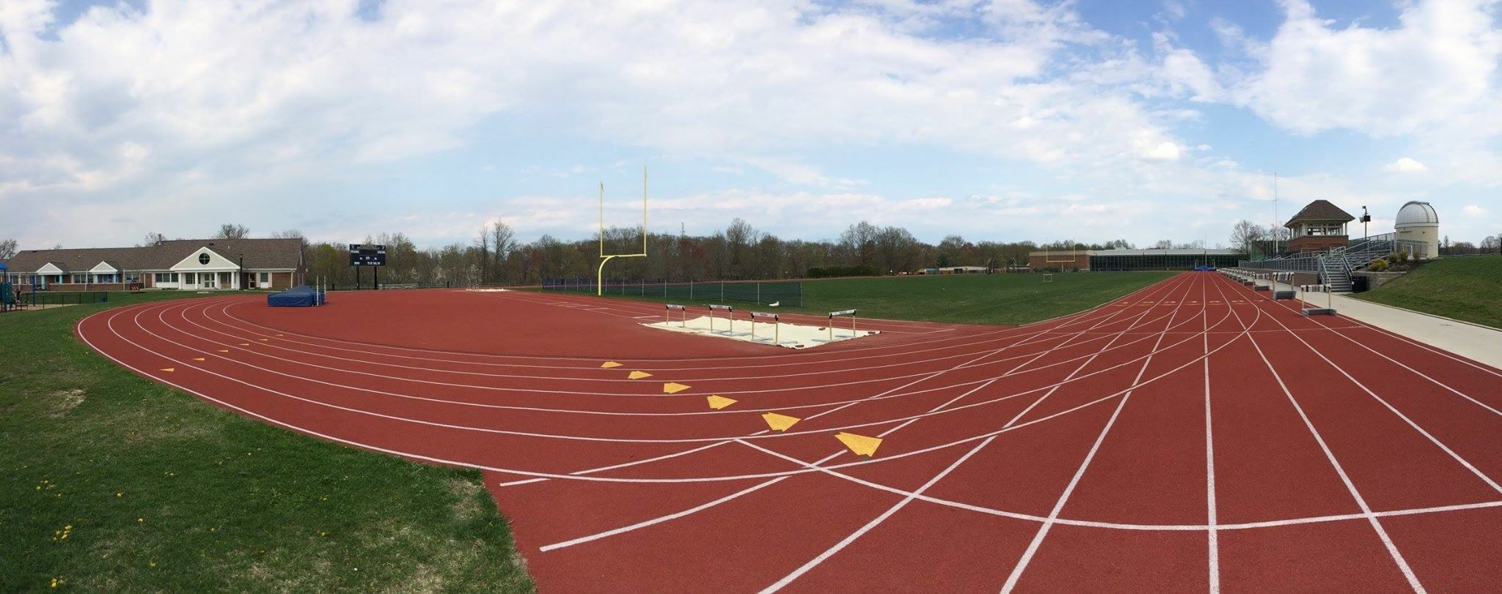

https://www.facebook.com/NewJerseyInternational

Over 40 NATIONS HAVE BEEN REPRESENTED OVER THE YEARS IN THE NEW JERSEY INTERNATIONAL MEET.
USA, Canada, Mexico, Great Britain, China, Chile, Kenya, Bahamas, Barbados, Australia, New Zealand, Belgium, The Netherlands, Belize, Bermuda, Brazil, Caymans, Costa Rica, Colombia, Dominican Republic, Ghana, Guyana, Haiti, India, Ireland, Israel, Jamaica, El Salvador, Sudan, Pakistan, Panama, Puerto Rico, Saint Vincent and the Grenadines, Dominica, Sierra Leone, Russia, France, Liberia, Serbia, South Africa, and Trinidad & Tobago, Togo.
2019 - 18 Nations
2018 - 17 Nations
2017 - 19 Nations
NJI Medal Club:
OLYMPIC OR WORLD GOLD MEDALISTS WHO HAVE COMPETED IN THE NEW JERSEY International Meet:
Roger Kingdom – 2-time Olympic Champion (USA)
Charles Austin (USA)
Butch Reynolds (USA)
Andrew Valmon (USA)
Lamont Smith (USA)
Eamonn Coghlan (Ireland)
Marcus O’Sullivan (Ireland)
Paul Ereng (Kenya)

